ELEC 2110

Electric Circuit Analysis

Gabriel Emerson

Jake Bryson

September 10, 2019

Section 002

DC Mesh and Nodal Analysis

Introduction

This lab tasks the student with using Nodal and Mesh analysis to solve multiple circuits. The student will be given a circuit and told to use Nodal and Mesh analysis on each one. Also, use MATLAB to solve the matrix equations.

Exercise 1

Analyze the circuit given using Nodal and Mesh analysis.

(1)

Circuit 1

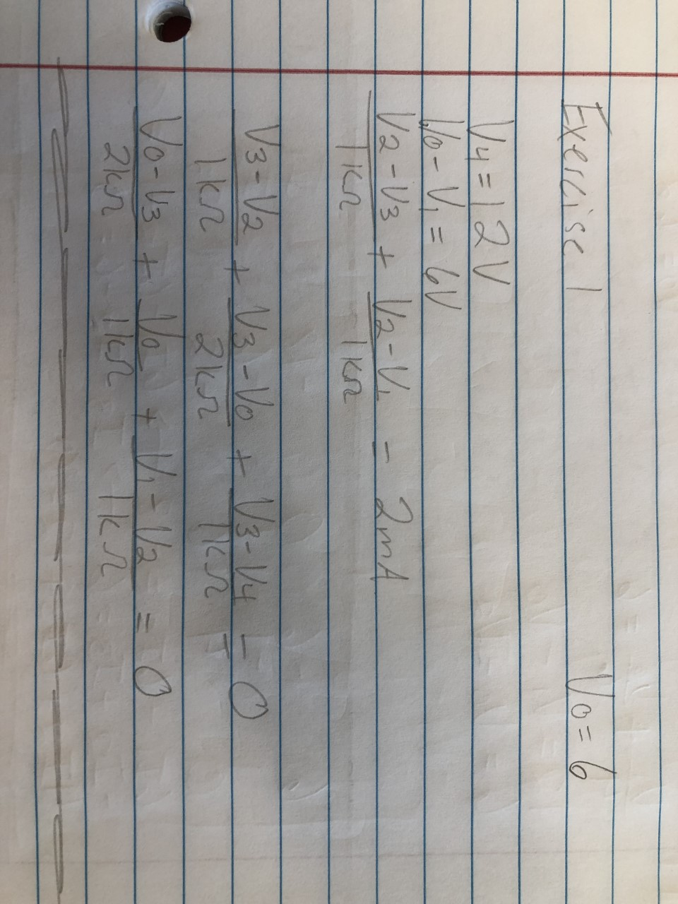

(2)

Nodal Analysis equations

(3)

Matrix Code and Answer

Nodal Summary Table

|  |  |
| --- | --- |
| V1 | 0V |
| V2 | 5V |
| V3 | 8V |
| V4 | 12V |
| Vo | 6V |

Mesh Analysis

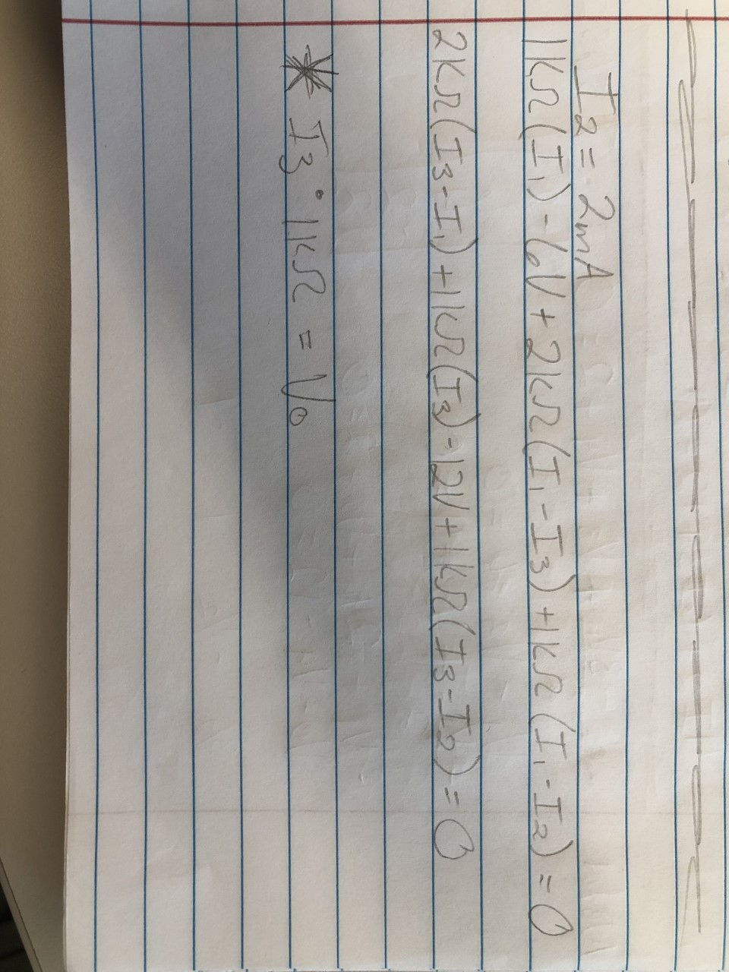

(4)

Mesh Analysis equations

(5)

Matrix Code and Answer

Mesh Summary Table

|  |  |
| --- | --- |
| I1 | 5mA |
| I2 | 2mA |
| I3 | 6mA |
| I3*1KOhms = Vo | = 6*1 = 6V |

Exercise 2

Given a new circuit, use Nodal and Mesh analysis to find voltage and current.

(6)

Circuit 2

(7)

Nodal Analysis equations

(8)

Matrix Code and Answer

Nodal Summary Table

|  |  |
| --- | --- |
| V1 | 19.2V |
| V2 | 1.2V |
| Vo | 7.2V |

Mesh Analysis

(9)

Mesh Analysis equations

(10)

Matrix Code and Answer

Mesh Summary Table

|  |  |
| --- | --- |
| I1 | -7.8mA |
| I2 | -4.8mA |
| I3 | 1.2mA |
| (I3*1)+6 = Vo | = (1.2*1)+6 = 7.2V |

Exercise 3

Given a new circuit, use Nodal and Mesh analysis to find voltage and current.

(11)

Circuit 3

(12)

Nodal Analysis equation

(13)

Matrix Code and Answer

Nodal Summary Table

|  |  |
| --- | --- |
| V1 | 0.6957V |
| V2 | 4.3478V |
| V3 | -5.3043V |
| V4 | -4.4348V |
| Vo | 7.5652V |

Mesh Analysis

(14)

Mesh Analysis equations

(15)

Matrix Code and Answer

Mesh Summary Table

|  |  |
| --- | --- |
| I1 | 1.8261mA |
| I2 | -2.1739mA |
| I3 | 3.1304mA |
| I4 | -2.0mA |
| I5 | 7.5652mA |
| Vo = I5*1KOhm | = 7.5652*1 = 7.5652V |

Exercise 4

Given a new circuit, use Nodal and Mesh analysis to find voltage and current.

(16)

Circuit 4

(17)

Nodal Analysis equations

(18)

Matrix Code and Answer

Nodal Summary Table

|  |  |
| --- | --- |
| V1 | 150.2609V |
| Vx | 31.3043V |
| Vo | -162.7826V |

Mesh Analysis

(19)

Mesh Analysis equations

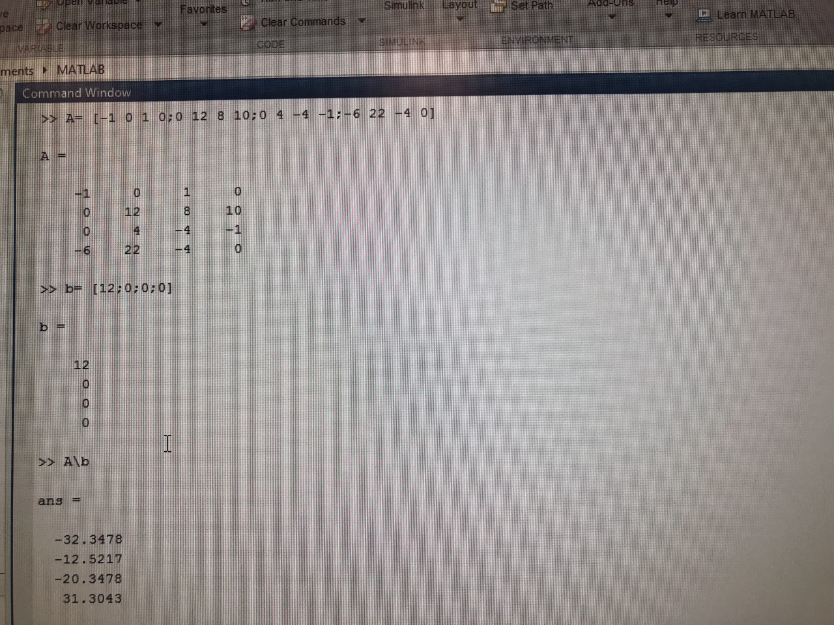

(20)

Matrix Code and Answer

Mesh Summary Table

|  |  |
| --- | --- |
| I1 | -32.3478mA |
| I2 | -12.5217mA |
| I3 | -20.3478mA |
| Vx | 31.3043V |
| Vo = (I3*8k) | = -20.3478*8k = -162.7826V |

Exercise 5

Given a new circuit, use Nodal and Mesh analysis to find voltage and current.

(21)

Circuit 5

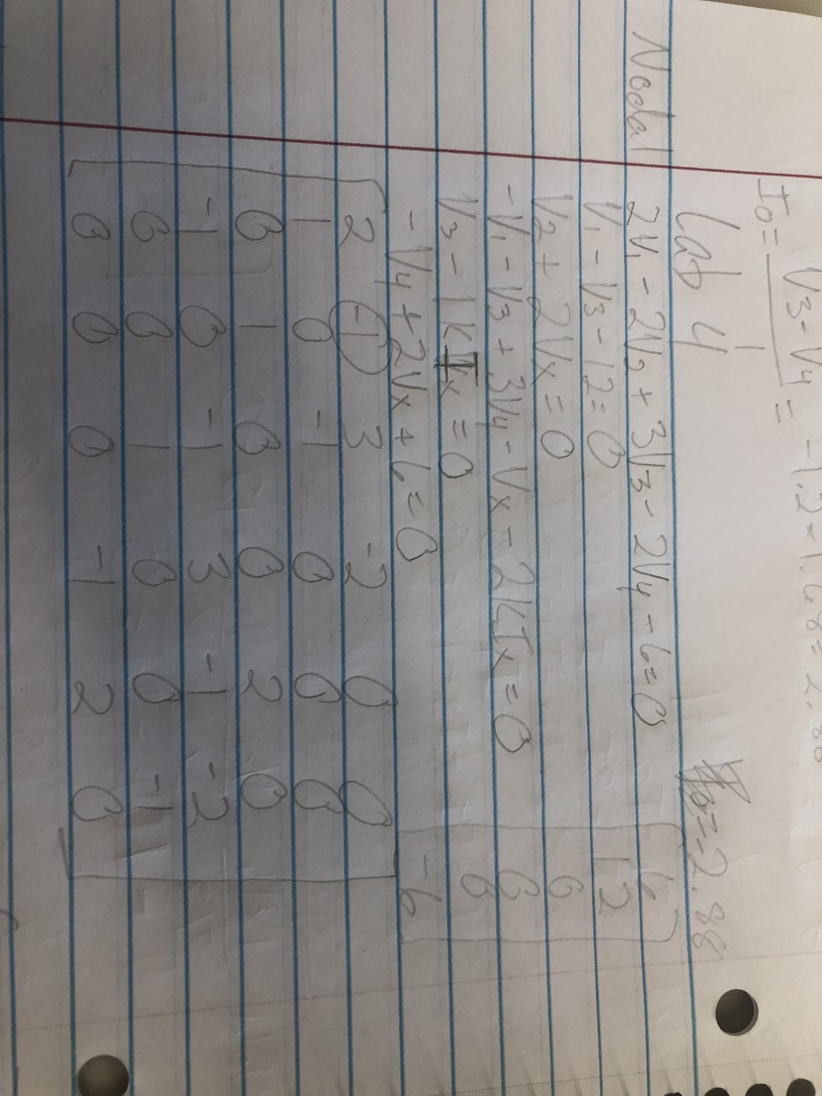

(22)

Nodal Analysis equations

(23)

Matrix Code and Answer

Nodal Summary Table

|  |  |
| --- | --- |
| V1 | 10.8V |
| V2 | 4.32V |
| V3 | -1.2V |
| V4 | 1.68V |
| Vx | -2.16V |
| Ix | -1.2mA |
| Io = (V3-V4)/1k | = (-1.2 – 1.68)/1 = -2.88mA |

Mesh Analysis

(24)

Mesh Analysis equations

(25)

Matrix Code and Answer

Mesh Summary Table

|  |  |
| --- | --- |
| I1 | -6.48mA |
| I2 | 3.12mA |
| I3 | -6.00mA |
| I4 | -0.96mA |
| I5 | 0.24mA |
| I6 | -2.16mA |
| Vx | -2.16V |
| Ix | -1.2mA |
| Io = I5 – I2 | = 0.24 – 3.12 = -2.88mA |

Bibliography

1. Circuit 1 given to analyze for exercise 1
2. Hand-written Nodal Analysis equations for exercise 1
3. Multisim matrix of answer for Nodal analysis exercise 1
4. Hand-written Mesh Analysis equations for exercise 1
5. Multisim matrix of answer for Mesh analysis exercise 1
6. Circuit 2 given to analyze for exercise 2
7. Hand-written Nodal Analysis equations for exercise 2
8. Multisim matrix of answer for Nodal analysis exercise 2
9. Hand-written Mesh Analysis equations for exercise 2
10. Multisim matrix of answer for Mesh analysis exercise 2
11. Circuit 3 given to analyze for exercise 3
12. Hand-written Nodal Analysis equations for exercise 3
13. Multisim matrix of answer for Nodal analysis exercise 3
14. Hand-written Mesh Analysis equations for exercise 3
15. Multisim matrix of answer for Mesh analysis exercise 3
16. Circuit 4 given to analyze for exercise 4
17. Hand-written Nodal Analysis equations for exercise 4
18. Multisim matrix of answer for Nodal analysis exercise 4
19. Hand-written Mesh Analysis equations for exercise 4
20. Multisim matrix of answer for Mesh analysis exercise 4
21. Circuit 5 given to analyze for exercise 5
22. Hand-written Nodal Analysis equations for exercise 5
23. Multisim matrix of answer for Nodal analysis exercise 5
24. Hand-written Mesh Analysis equations for exercise 5
25. Multisim matrix of answer for Mesh analysis exercise 5